Nick Dean, Portfolio Project

Introduction –

My portfolio project idea is going to be a Gaming journal that will allow enthusiasts, casual and professionals, to keep track of their hobby. Between life’s constant demands, we find it hard to immerse ourselves in our hobbies and eventually forget where we left off when we decide to come back to it. We often organize our work and our chores in a way that prevents this, so why not organize our hobbies? The gaming journal will be geared towards keeping track of video game progress and will live on your phone to help keep you connected to your passion for gaming without losing track.

User interface Design and Prototype –

The design will be as simple as logging or reading a journal entry:

* The home page would feature an immediate view of your games. There will be a radiobox that allows you to control whether you’re viewing your consoles or your games. There will be a carousel towards the bottom of the page that will display the data that you’re indicate in the dropdown. There will also be a search bar for easy access.
* Also on the home page will be a button or two for you to easily add a new game/save record that you’re following to your library
* Each game page will feature input fields for “Gaming Guide(s)”, “Recap”, “Where to Next?”, “Goal(s)”, Notes, and possibly more but I would want to keep it as simple and easy to use and revisit as possible.

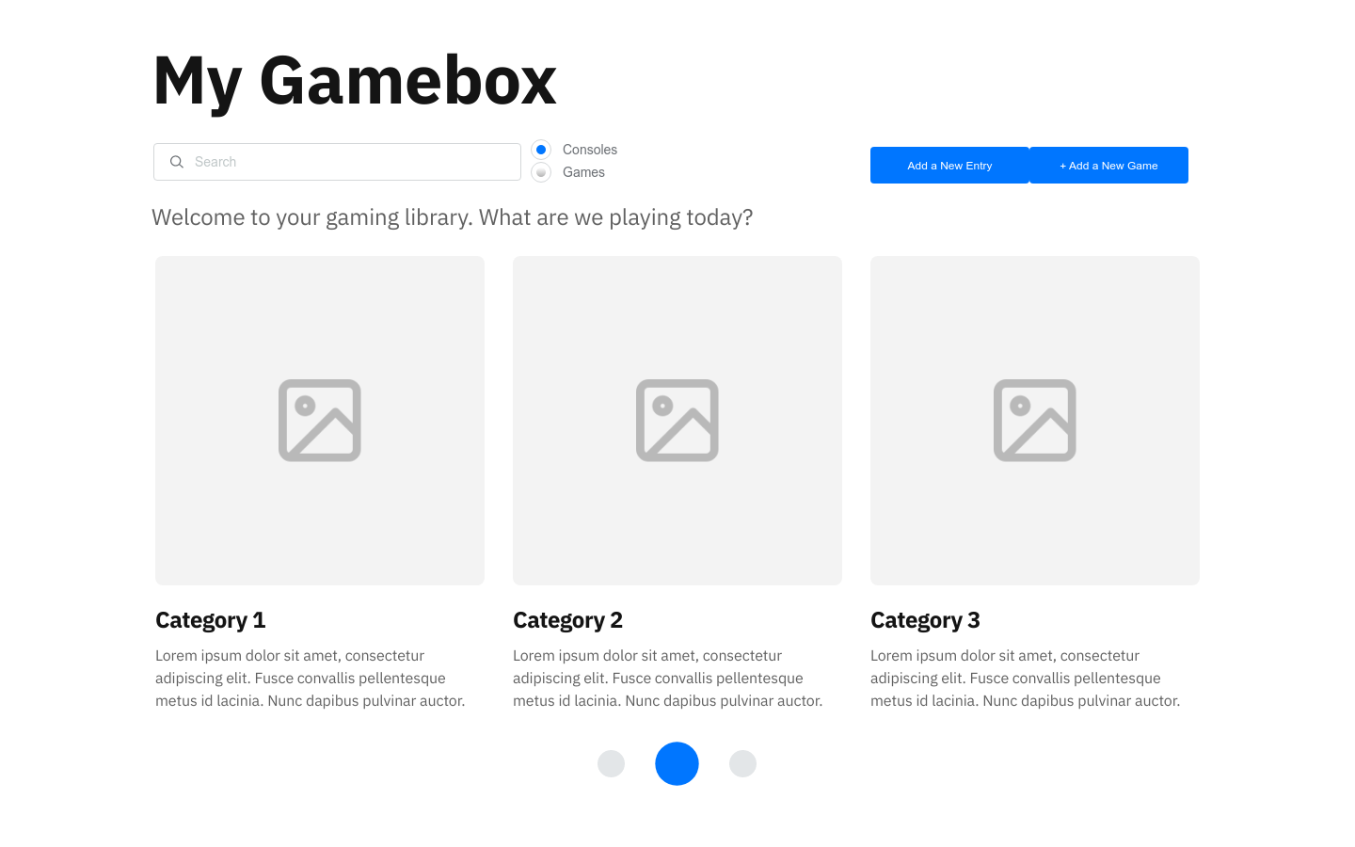

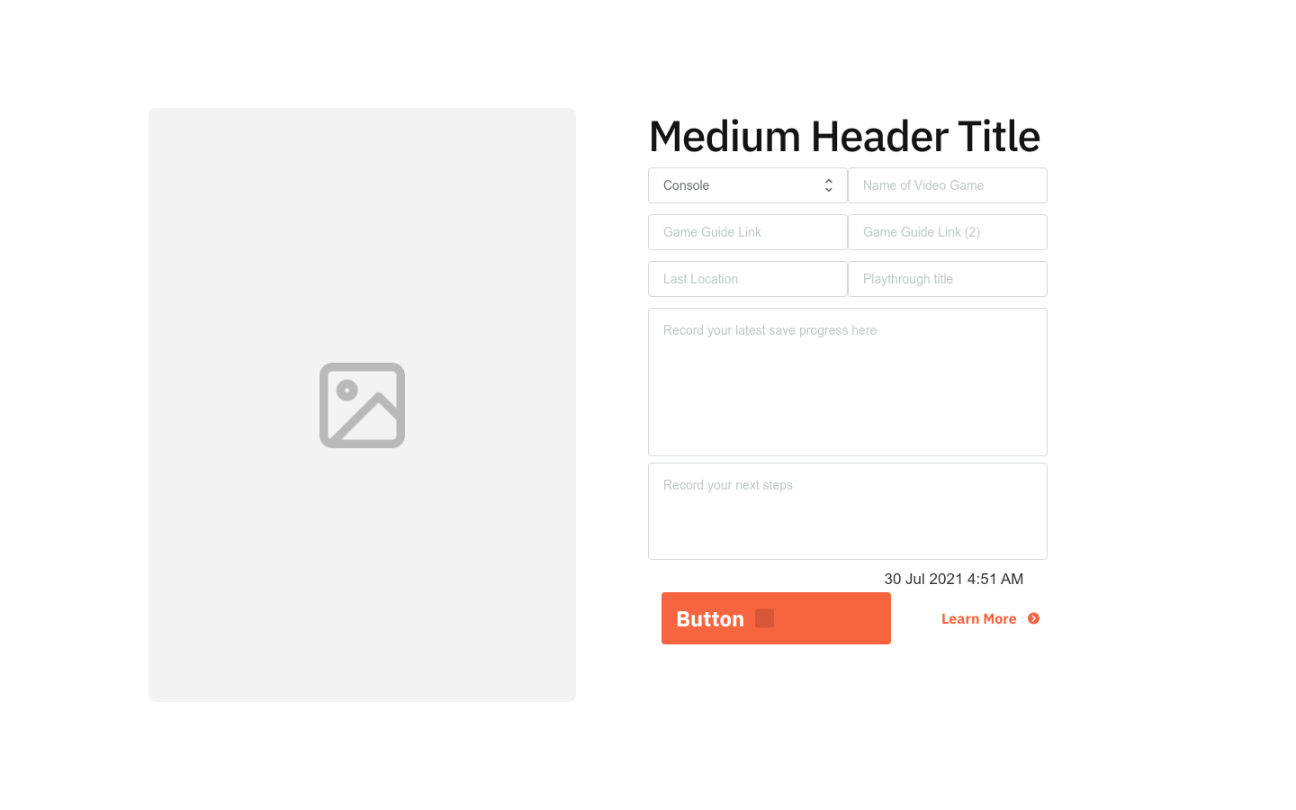

Navigation Source –

I’ve always been a big fan of the minimalistic navigation bar structures. To keep the site as simple as possible, I’d like to have only a few layers:

* The home page as the starting point with “My Gamebox at the top left of every screen to easily return.
* A small breadcrumb bar that helps the user find where they are on the site. The console pages will be nested to the Index pages and the video game pages will be nested to the console pages. From there, the save record pages will be nested under the video games. This mimics traditional games with save points (such as Final Fantasy).
* A typical user should be open to open the index and whether they search for a console or video game, they’ll be taken 1 or 2 levels down. From there they’ll be able to access their playthroughs and save points. If multiple records are being managed, they will be able to click back to the console easily to see which games they have assigned and choose another game and proceed down the sitemap again to their playthroughs and save points.

References –

* Proto.io was used to create this prototype